**VIP Team Contract Template**

*This document is a binding contract that will be used to help hold each member accountable for team expectations and help with work-load distribution and conflict resolution. Each team member should keep a copy of this contract. Use this template for suggestions. Teams can create their own contract and do not have to follow what is written below.*

**Team Members**

Name ______Chenyu Li_______________ Email _____cli774@gatech.edu___________ Phone______470-855-0352__________

Name Nathaly Jose-Maria Email njosemaria3@gatech.edu Phone 678-914-8982

Name Shinhaeng Lee Email slee3487@gatech.edu Phone 480-201-7331

Name Vedika Bhatnagar Email [vbhatnagar30@gatech.edu](mailto:vbhatnagar30@gatech.edu) Phone 470-418-1733

**Expectations**

What are the expectations you have for your team members? How will you communicate with your team members? How responsive do you expect team members to be? What is your strategy for distributing work within the group? Will you rely on the skills of individual team members?

The biggest expectation is to simply be responsible, particularly with communication. Communication should be as prompt as possible, but more so with an approaching deadline. Work will be distributed as fairly and equally as possible in terms of intensity and time of responsibilities. Team members should play to their strengths, but because of each individual’s interests, we will also balance focus on personal exploration and discovery.

Additionally, given the circumstances of our team, we will be more flexible with professionalism guidelines. In order to gain full credit for professionalism, we will be accommodating of issues, but not strict in requiring a “zero issue” expectation. Likewise, given the circumstances, a response within 24-hours may not be possible; therefore, this expectation will be more flexible as well in order to accommodate.

**Strengths/Skills**

List the strengths and skills each team member brings to the team. Consider reliability, punctuality, flexibility, leadership, writing skills, light semester load, model-making/prototyping, 3D modeling experience, presentation-skills, electronics, programming, accessibility to campus, visual communication, etc.

* Chenyu Li
  + I live on the west campus and I usually study at culc.
  + I’m a chemical engineering freshman and am generally familiar with biology and chemistry.
  + Currently I’m learning Matlab and I learned Java in high school.
  + Very punctual and flexible.
* Nathaly Jose-Maria
  + I live on-campus.
  + I have experience programming in various languages, particularly Python for data processing, Java for ubiquitous computing, and SQL for data management.
  + I have experience with some modeling particularly with Unity.
  + Generally very flexible as long as there is open communication and trust.
  + I will gladly put my neck out for the group if it comes to presentations, asking questions, etc, I just ask that I am not the only one responsible for this.
  + Generally a good writer.
  + Generally punctual.
* Shinhaeng Lee
  + I live on-campus (GLC).
  + I’m currently studying computer science as a junior. I am quite familiar with Java and C++ and have some experience with PyTorch and Linux OS.
  + Generally punctual and flexible
* Vedika Bhatnagar
  + I live on campus (Brown).
  + I am a CS freshman. I have experience programming in Java, Javascript/HTML/CSS, and Arduino, and some experience with C++ and Android Studio.
  + Generally punctual, flexible especially with prior communication, and a good writer.
  + I am good at making and delivering presentations.
  + I am generally good at, and enjoy, project management/leadership- breaking down goals, dividing work, organizing meetings, and ensuring everything is complete and turned in on time.
  + My weekends are usually completely free, so I can work on things over the weekends.

**Potential Conflicts**

For each team member disclose the possible impacts on project participation, so that these can be anticipated and worked around. These are not an excuse for poor participation, but rather a way to solve possible issues before they arise. Heavy semester load, other commitments (athletics, work, etc.), family responsibilities, commuting, shyness, poor writing skills,

● Chenyu Li

* I’m currently taking six courses and also working on some competitions and athletic races, so maybe I would be kind of busy near midterms and get a little distracted from the project. I’ll talk about these with the team in advance if some time conflict arises and I promise I will do my part no matter what.
* I’m an international student and my English is not as fluent as the native speakers, so sometimes I may not express myself precisely. Please bear with me if my words cause any misunderstanding.I will do my best to engage in discussions and contribute to the team.

● Nathaly Jose-Maria

* I work part-time in the College of Computing. Usually little to no work, but some weeks will be particularly busy compared to others depending on what events are going on that I will have to help plan and host. I will advise in advance when these events/busy times are with as much advanced notice as possible, but if that is not possible, I simply ask for flexibility and patience as we work to resolve our issues.
* I have severe anxiety and depression registered through the Office of Disabilities that makes some days harder than others. I am usually fine, but I will occasionally have time periods, anywhere from a few hours to a few days, where I need to take time to simply reset away from all of my activities. This happens typically every month or so. Because of this, I may be unresponsive in these moments, but I will do my best to communicate these periods and the times in which I am able to bounce back ready to work again.
* Weekends are harder for me to have regular meeting times with as mine tend to be very variable. I often drive home to help watch my sick father. If I stay on campus, I try to regulate my mental health to ensure I do not have any anxious or depressive episode during the week. I am unsure if this will be an issue, but I thought to communicate clearly in advance.
* I can be quite introverted, so I may seem disinterested, but I promise I listen attentively and am actively engaged in conversation and activities. I love hearing from others and their work, and I would especially love to help and contribute in any way I can.

● Shinhaeng Lee

* I have a quite hectic schedule during the weekdays, but I will try my best to communicate with my teammates and work on the project, so no worries regarding these things. I am very open-minded enough to listen to my teammates concerns so I am always ready to communicate with them if any problems arise. If some unexpected issues happen to me, then I’m definitely going to tell my teammates immediately.
* I’m an international student as well, which means I may not be fluent in English sometimes, but I promise I will try my best to communicate with my teammates and to enthusiastically participate in conversation and meeting.

● Vedika Bhatnagar

* I am dealing with severe health issues, which is why I am taking a 12 hour semester. I also have accommodations registered through ODS for anxiety, depression, and physical health issues. I will almost always be able to communicate about these things as they come up, but there is some uncertainty about my health.
* Because of health problems sometimes, I may not be able to walk to the library/etc to have a meeting in person. I can join virtually or we can try to find closer locations if this occurs.

**Meeting Times**

Please list possible times for meeting with teams member outside of class. Please be sure to list any black-out dates and times.

Lettuce Meet with members’ availabilities: <https://lettucemeet.com/l/WKdj8>

Weekly meeting time: Tuesdays at 1pm

**Methods of Communication**

1. How will your team communicate? Will you use a group messaging platform, text message, phone call, email, video calls, etc.?

Groupme (primary), email (secondary), phone call

2. How quickly is a response expected to communications – within 2 hours, within 24 hours, etc.? Should all team members acknowledge receipt of communications?

Within the day (24 hours). The team members should acknowledge receipt of communications.

3. Will you have in-person meetings, and if so, how will you adhere to social distancing requirements?

Yes, we will have in-person meetings in Price Gilbert Library. Will coordinate specifics with each meeting. Reserve room as needed. However, given the circumstances of our members, we will also do a mix of virtual meetings as needed.

4. Describe your strategy to effectively work remotely and collaborate. What platform will you use for video conferencing, sharing documents, and collaboration? This is an essential component of team-based design.

Bluejeans for remote meeting; Google doc (shared drive folder), email & Groupme for sharing documents and collaboration.

**Conflict Resolution Plan**

Since part of your grade is based on peer review, please outline your strategies for dealing with the following team issues: tardiness, absenteeism, slacking off, missed team deadlines, etc. Will you institute a 3 strikes you’re out policy? Or will it be trial by jury? How will your group deal with these issues within the group? At what point will you involve the TA/Instructor?

Trial by jury is the most fair option. We are all busy individuals with different things going on, so sometimes things might not go to plan. In order to maintain this trust, we will own up to our responsibilities and mistakes and do what we can to uphold them. On the basis of communication, we will remind or “nudge” each other when deadlines are approaching. Should an individual need to be reminded frequently, a group meeting will take place. If changes are still not implemented, an instructor will get involved.

***I have read and understand the expectations and conflict resolution plan outlined in this document, and agree to follow this plan in an effort to have an equitable and harmonious project experience.***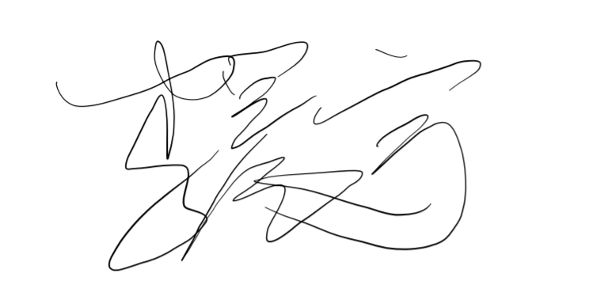

____Chenyu Li________________________ ______________________01/25/2022______

Team Member 1 Printed Name Signature Date



Nathaly Jose-Maria 01/25/2022

Team Member 2 Printed Name Signature Date

Shinhaeng Lee ____________________ ____01/27/2022

Team Member 3 Printed Name Signature Date

Vedika Bhatnagar 1/25/22

Team Member 4 Printed Name Signature Date

Witnessed By:

____________________________ ________________________________ ____________

Instructor Printed Name Signature